**ReplicaSet**

Let’s imagine that we want to deploy containerized app inside kubernetes cluster.

Ex:

**How can we ensure there are at least 3 pod Instances are always available and running at point in time?**

**Replica Set** (Next generation of Replication Controller)

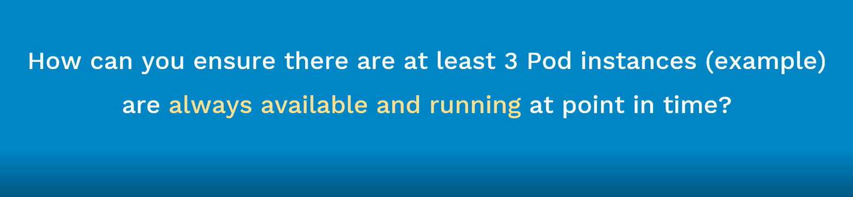



Before, we learning about the ReplicaSet, we should get an idea of the ReplicationController and Kubernetes

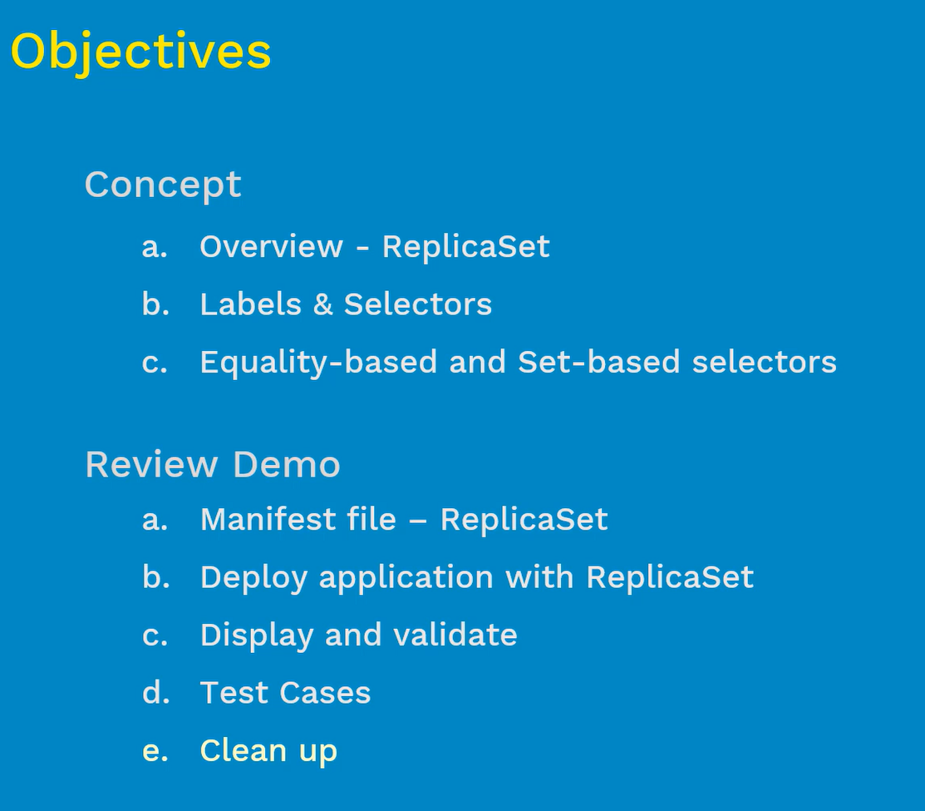

# ReplicaSet Overview:

* It ensures that specified number of pods are running at any time(always) – { Eg: If we define 5 pods in ReplicaSet, then this set make sure 5 pods will running always}

1. If there are excess pods, they get killed and vice-versa – (In case, there are too many pods are running, then what was defined in the manifest file? Then ReplicaSet will terminate the extra pods)
2. New Pods are launched when they get fail, get deleted or terminated – ( If pods were less than the defined in the manifest file, the ReplicaSet will start more pods, sometimes pods do fail, deleted or die for various reasons- when they do, if they were back by the ReplicaSet then these pods will get automatically re-created on same node or another healthy node }
3. The best practice and good idea for the ReplicaSet make the value as 1.

One very important point note here is,

**How this ReplicaSet does aware of the pods that need to manage?**

**What is the relation between the ReplicaSet and pods need to manage? Answer is ‘Labels’**

* ReplicaSet and Pods are associated with “Labels” – { Labels are nothing but “tags” that given to the PODS, Using Labels that we will relate the ReplicaSet to pods that its need manage, here we will mention the exact labels inside the pod and the ReplicaSet }

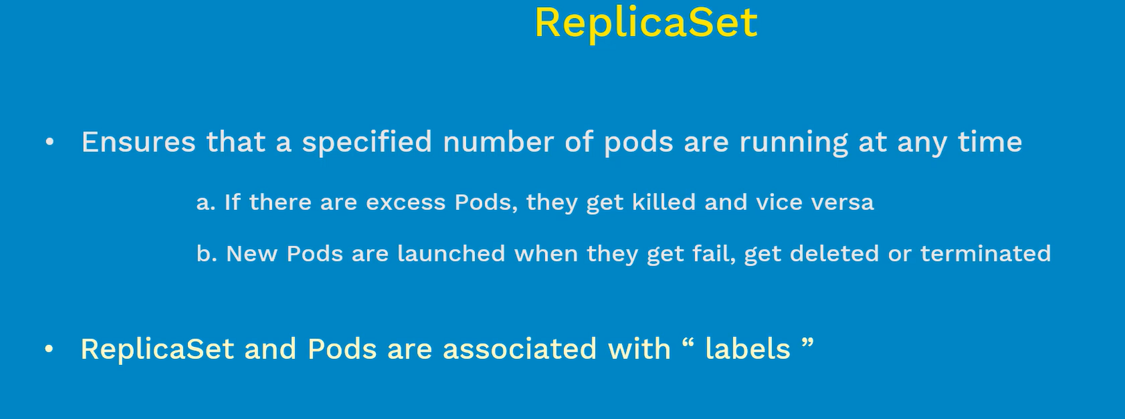

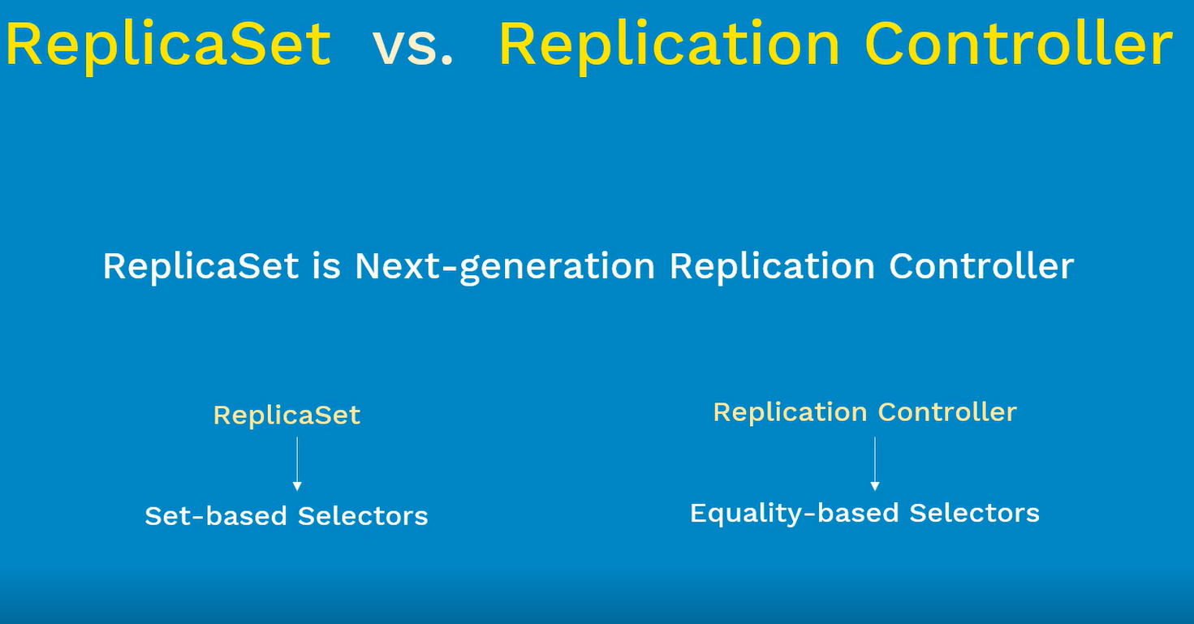

|  |  |  |
| --- | --- | --- |
| S.No | Replication Controller | ReplicaSet |
| 1. | Replication Controller uses Equality-based Selectors | ReplicaSet uses Set-based Selectors |
| 2. | Old Generation | Next Generation of Replication Controller |
| 3. | Labels | Selectors |
| 4. | It supports only Equality-based selectors | It supports both Equality- based and set-based selectors |

As we know, pods are basic scheduling in kubernetes (just like VM in VMware world). These pods will provide a run-time env for application that we deploy. So when we deploy the applications to have a better HA and Load Balancing between the applications we tent to deploy multiple instances of the applications. So there will be one pod per application instance and if you scale your application instances to 10, there will be 10 pods.

**How these pods are can manage at such large scale?**

These were usually manage by Controllers and Services such as **ReplicationController, ReplicaSet, Services, DaemonSet** and so on.

Here main question is, **how do these controllers and services are aware of pods that needs to manage?**

**Labels and Selectors**

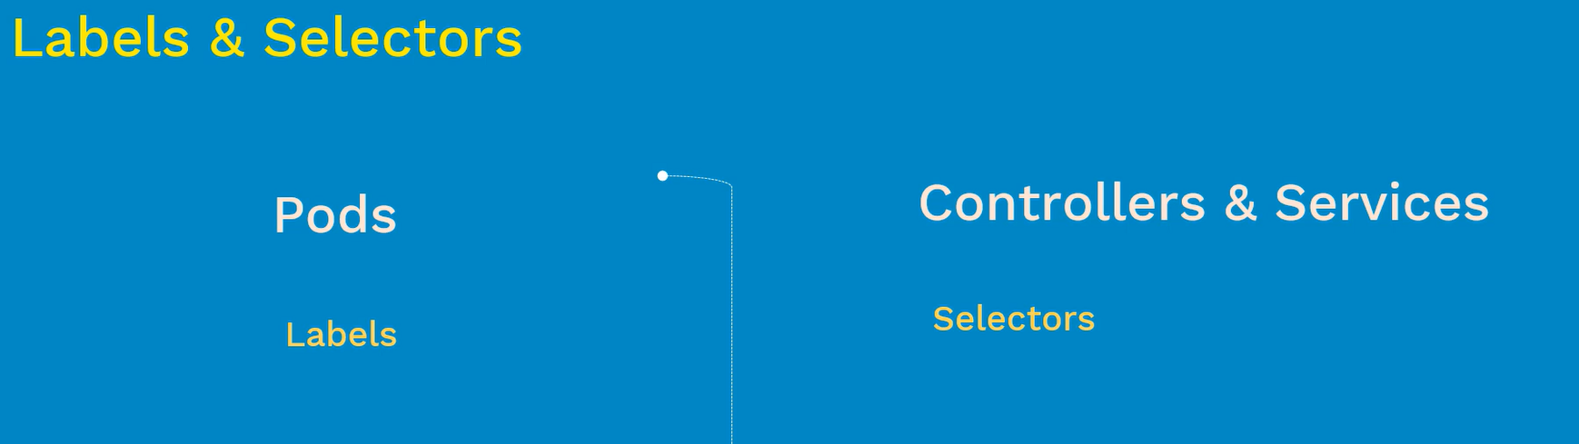

* Labels are key-value pairs that are generally attached to pods. It is kind of a tag that given to one or set of related pods together and it will help us displaying and managing pods together as a set instead of individual
* Take example of below pod-spec file

1. Below we have pod name as nginx-pod
2. It has three labels, we can see app, tier and env
3. App is **Key** and guestbook is **Value,**  this way we are defining labels inside pod
4. These were the tags that we define to the nginx-pod
5. This pod-spec will deploy five nginx pod instances inside our kubernetes cluster
6. All these five pod instances has same labels
7. On other side, we have selectors.
8. Controllers & Selectors manage these five pods using the **SELECTORS**
9. Any guess, what goes inside these selectors? **POD Labels**
10. There are two different ways to define selectors

Old way – Equality Based Selector – Used in Replication Controller

New Way – Set Based Selector – Used in ReplicaSet

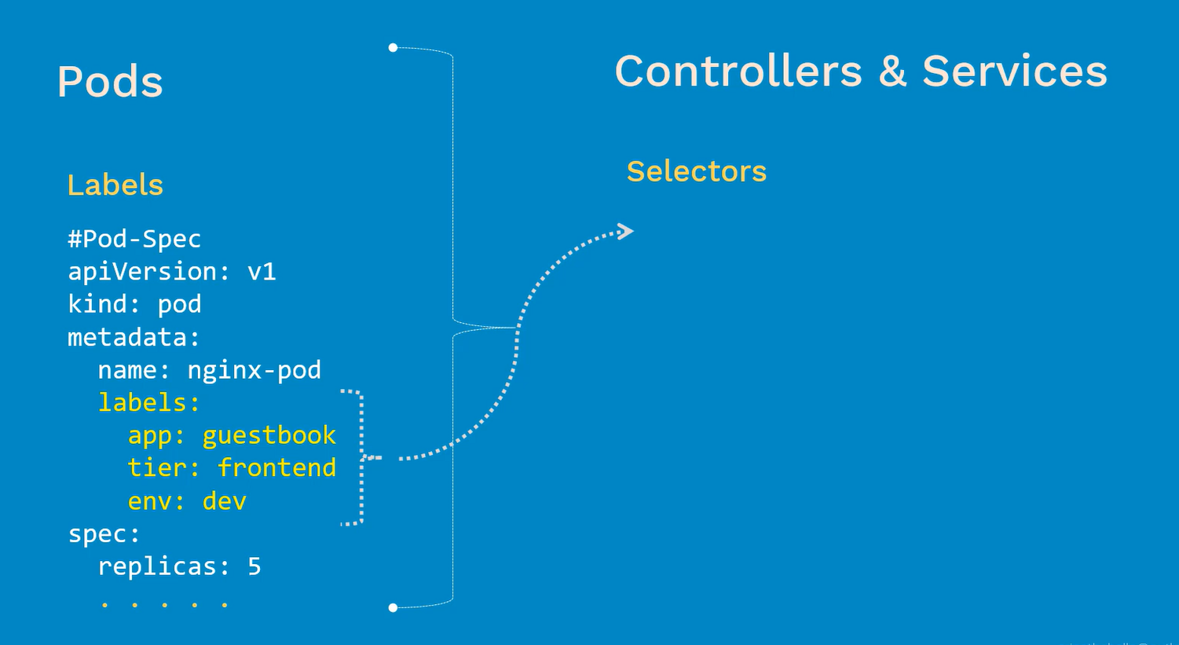

|  |  |
| --- | --- |
| **Equality based Selector** | **Set based Selector** |
| There are three kind of operators used in here  = - equal to  == - double equal to  != - Not equal  First two operators are same, you can use either one of them | There are three kind of operators in here  In  notin  exists |
| Example:  Environment = production  Tier != frontend  **Explanation:**  In the first example, All pods in the production env  In the second example, all tiers except frontend | Examples:  Environment in (production, qa)  Tier notin (frontend, backend)  In set-based selectors, we can give two or more options. This is the primary advantage of set-based selectors  **Explanation:**  In the first example, we are selecting the pods are in both production and QA environment  Second example, we are selecting all pods who are not in frontend and backend |
| Command-line  # kubectl get pods –l environment=production | Command-line  # kubectl get pods –l ‘environment in (production) |
| Manifest file:  ….  Selector:  Environment: Production  Tier: frontend  …… | Manifest file:  …….  Selector:  matchExpressions:  {key: environment. operator: In, values:[prod, qa]}  {key: tier, operator: NotIn, values: [frontend, backend]} |

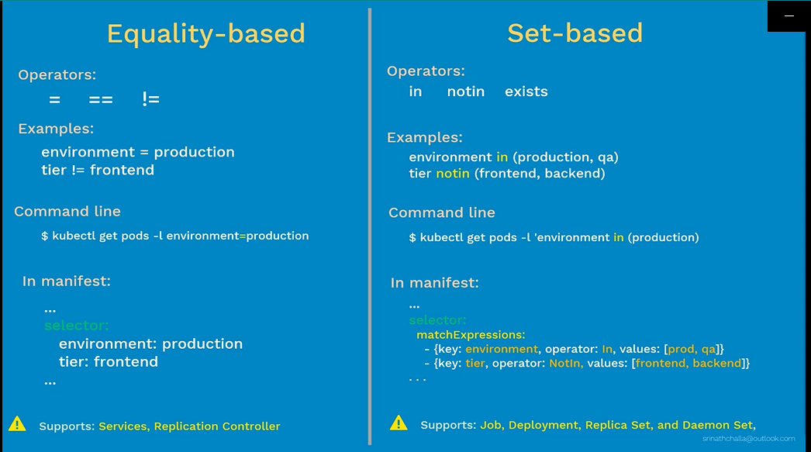

If you look at these very high level, we will get like two points

* Equality-based selectors are easy to use and understand but less powerful than set-based selectors
* Set-based selectors are bit complex, more powerful than equality-based selectors

So which one to use?

It depends on your requirement. If you just learn the kubernetes, you can start practice with Equality-based selectors then once you are comfortable with you can start with set-based selectors as when we needed.

In our demo, we will deploy applications with both examples

Before moving to demo, we must clarify about the **matchLabels**

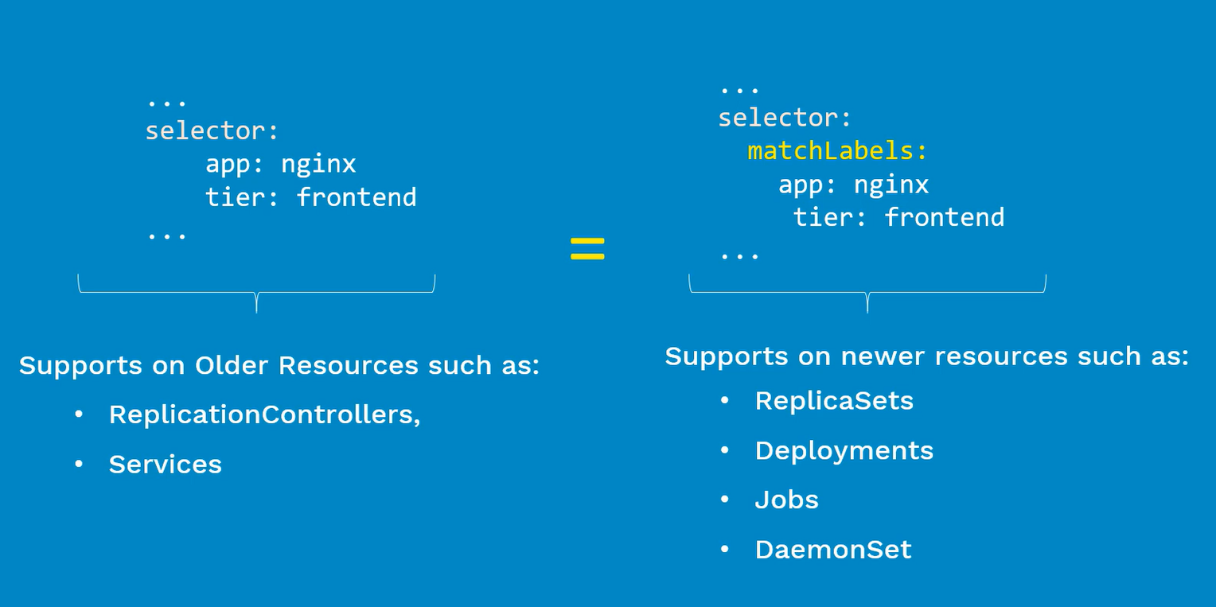

**VeryImp: It will confuse a lot, please remember when are going to practice**

As we can see spec file with two different variables, one with **matchLabels** other without **matchLabels,**

* We use selector without matchLabels on older resources like **ReplicationControllers** and **Services**
* We use selector with matchLabels on newer resources such as **ReplicaSets, Deployments, Jobs** and **DaemonSet**

# Review Demo

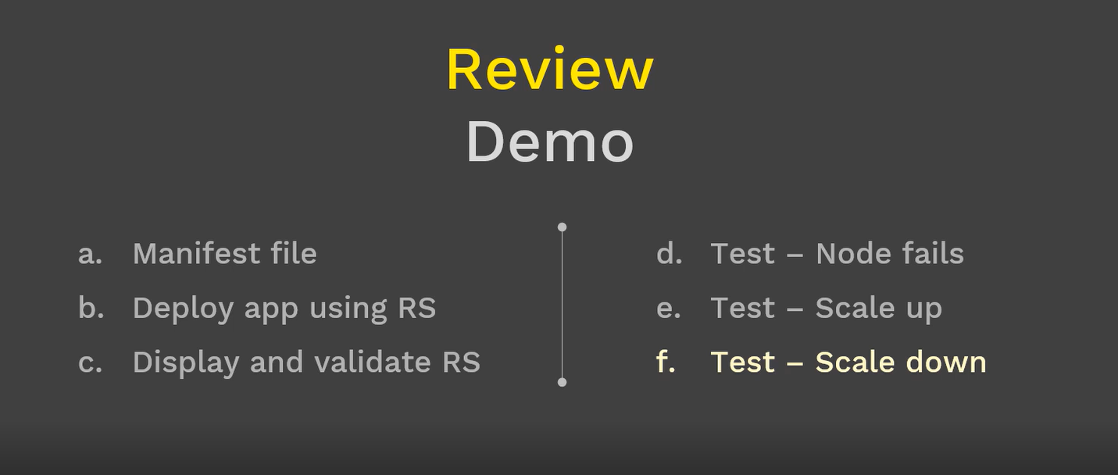

### ReplicaSet – Manifest File

ReplicaSet Manifest file consists of four top sections – apiversion, kind, metadata and spec.

**apiVersion** – we are configuring as apps/v1

**Kind** – kind of the object that we are creating here is ReplicaSet

**Metadata** – two things that we are defining in this section- name and Labels

**Spec –**

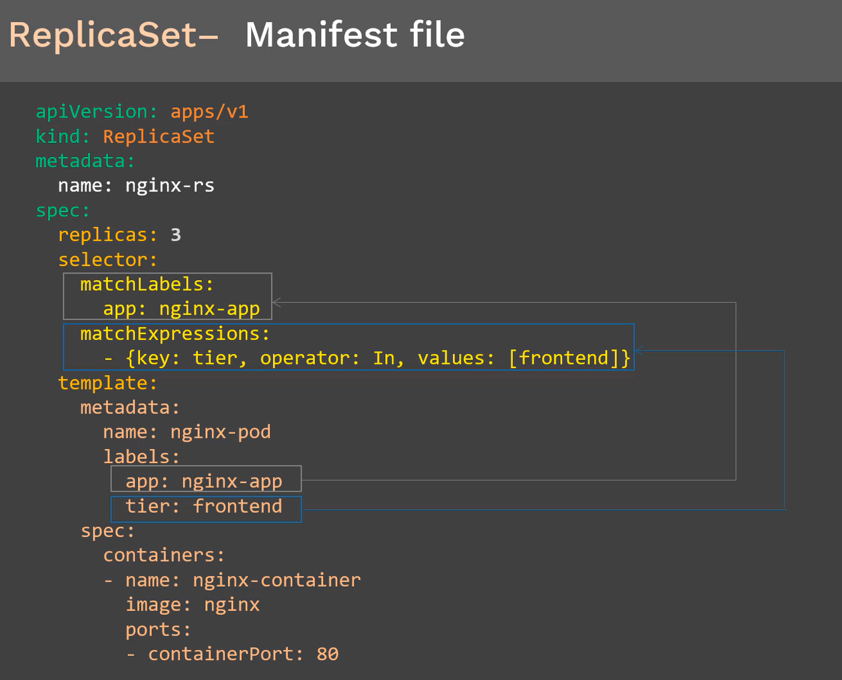

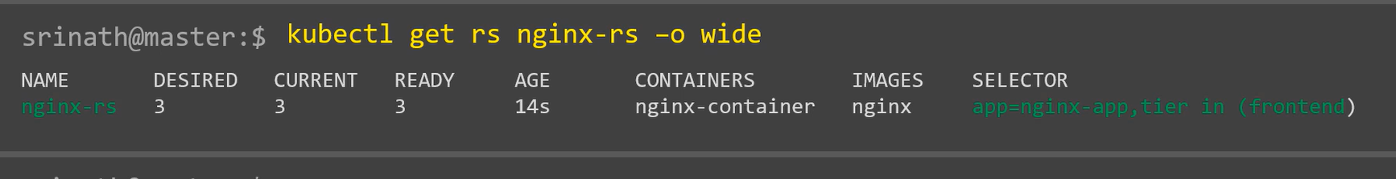

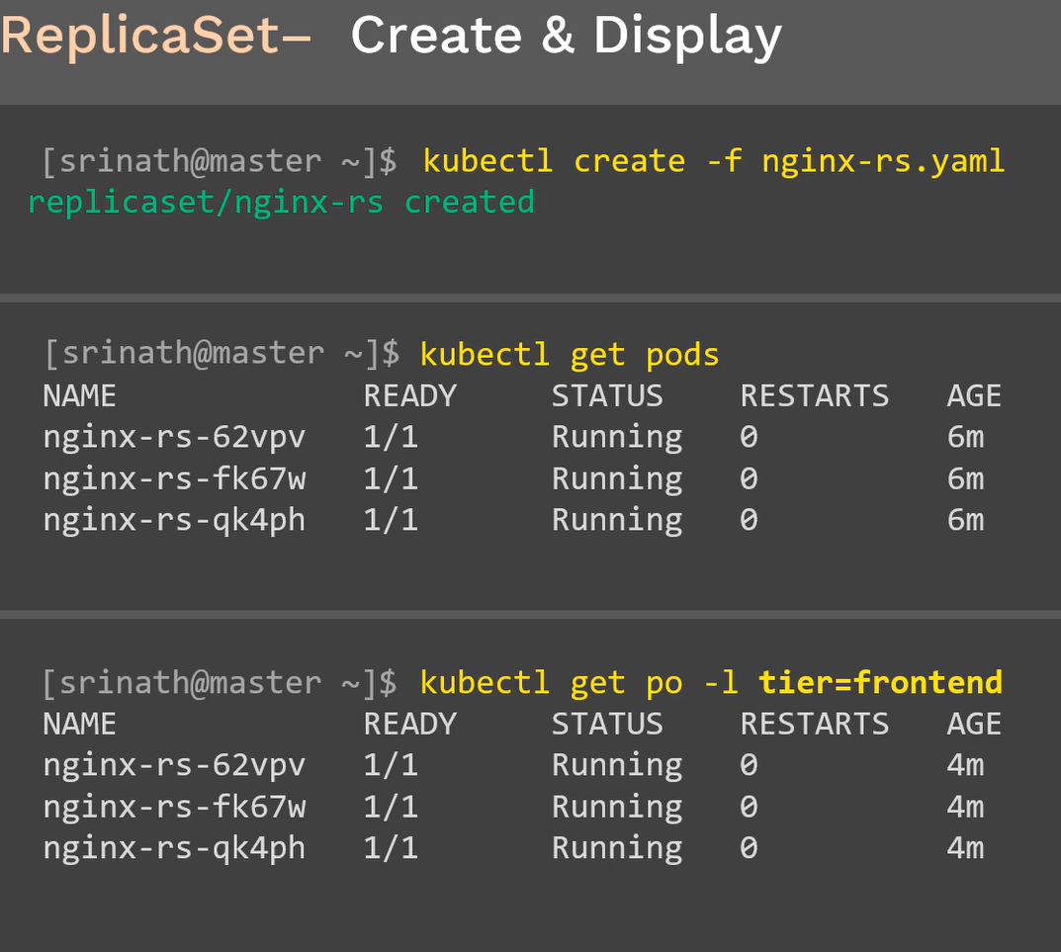

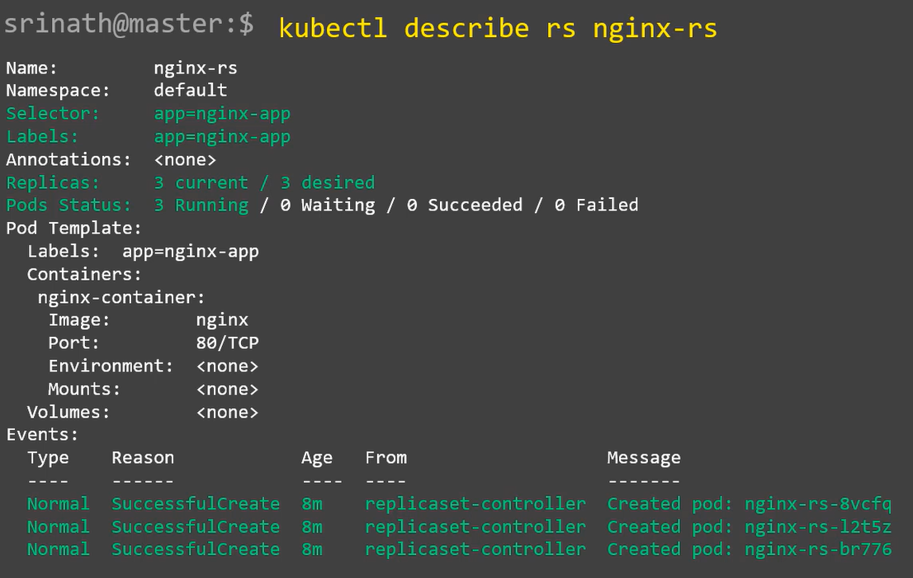

## ReplicaSet – Scheduling:

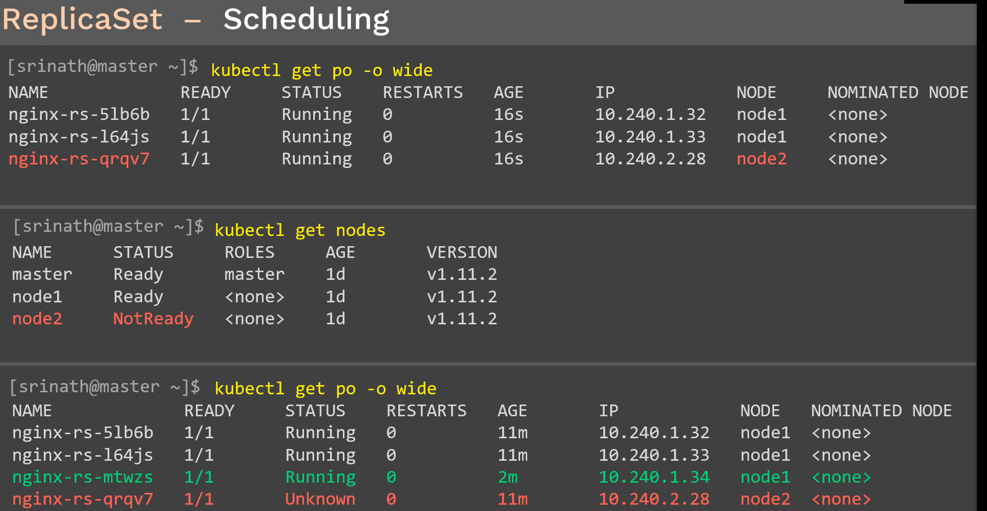

## ReplicaSet – Scaling Up:

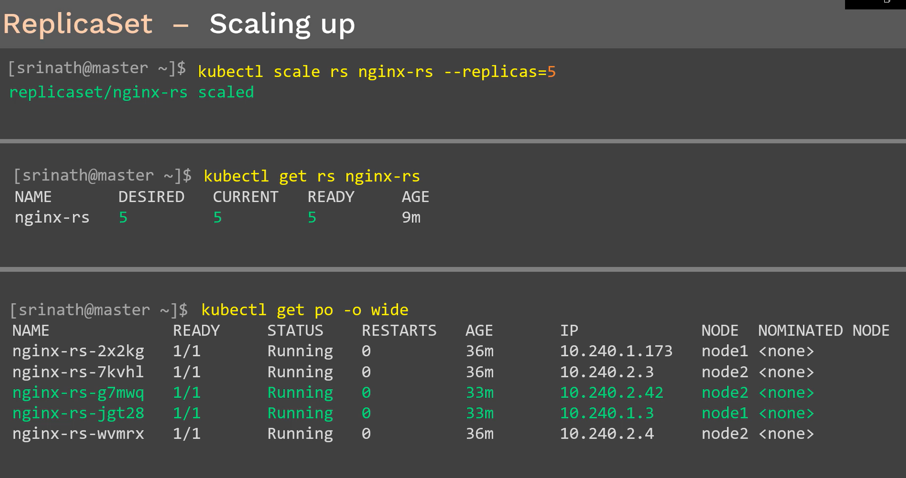

## ReplicaSet – Scaling down:

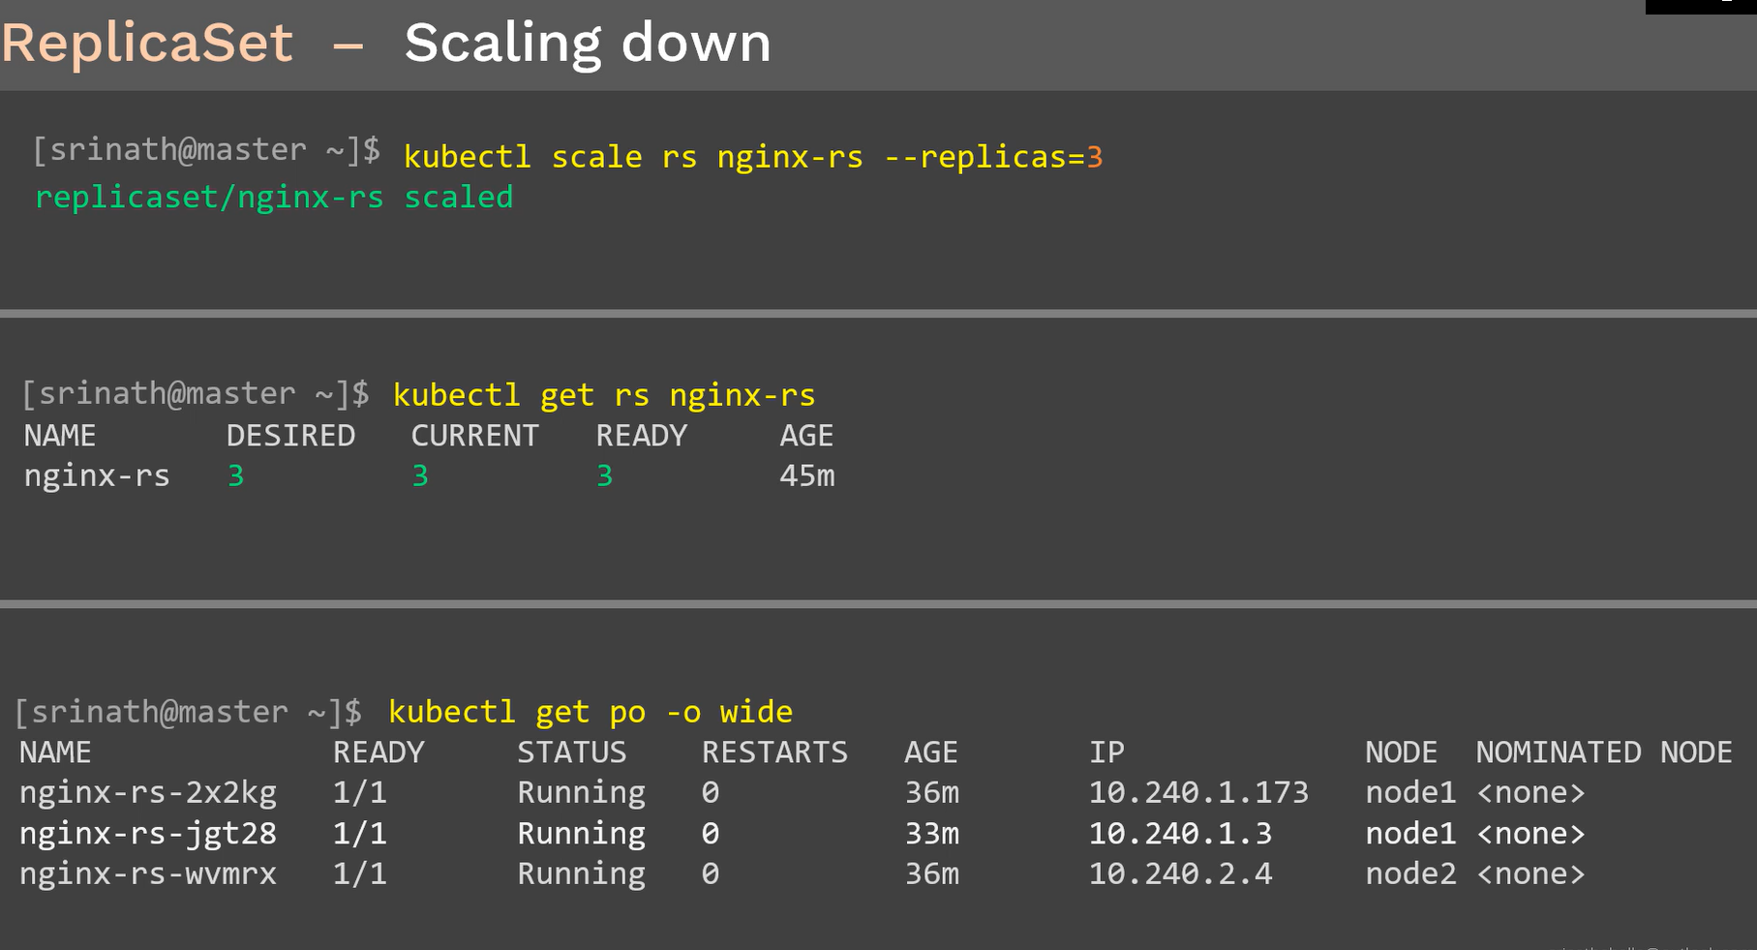

## ReplicaSet – Delete

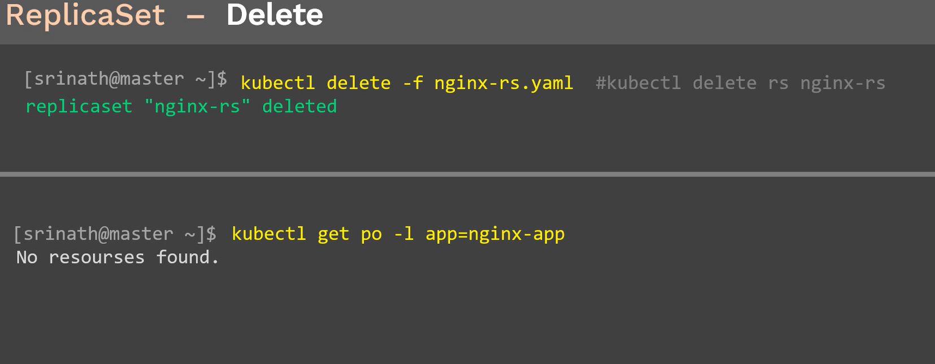

Summary:

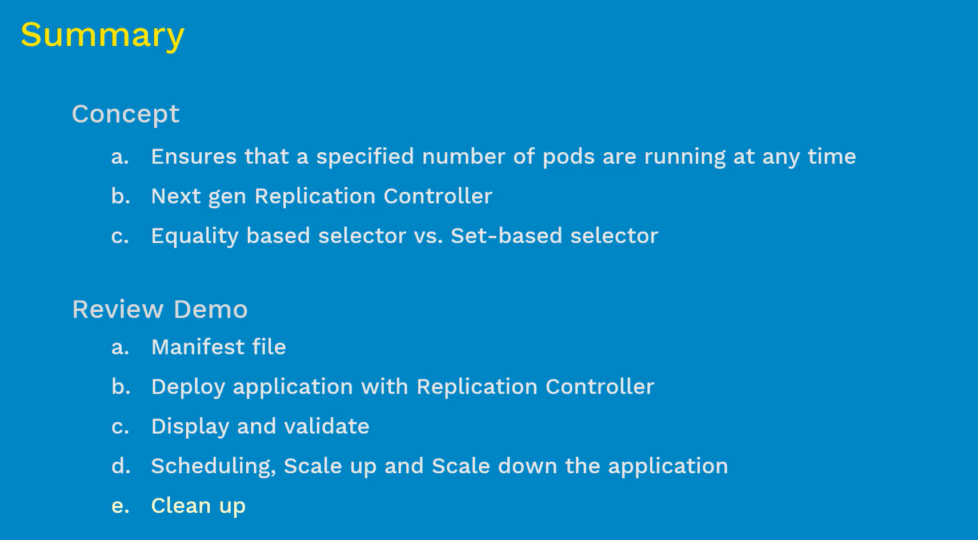

Demo



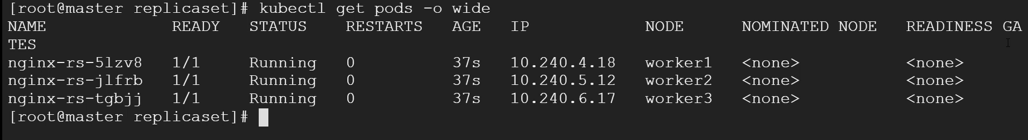

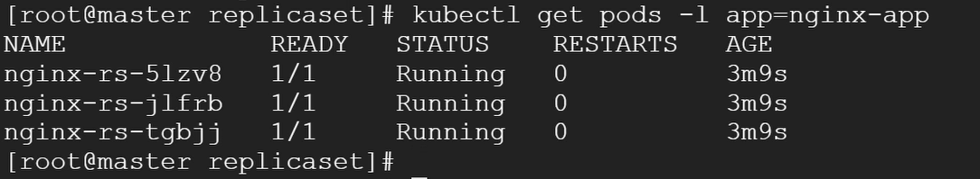



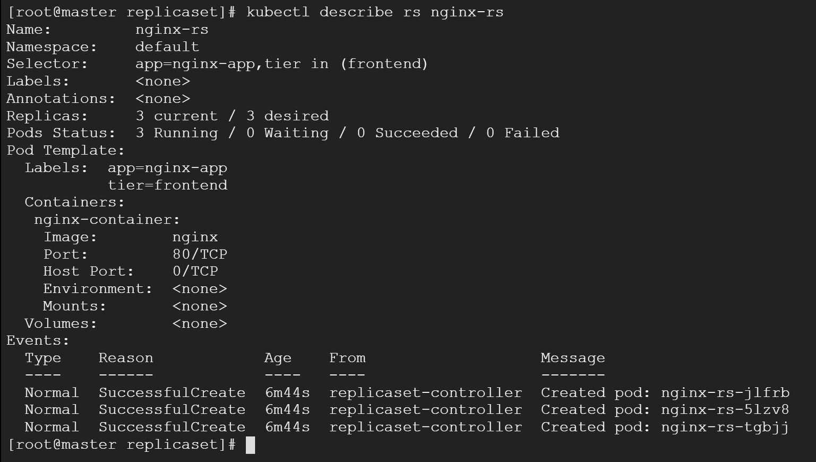

### Reschedule:

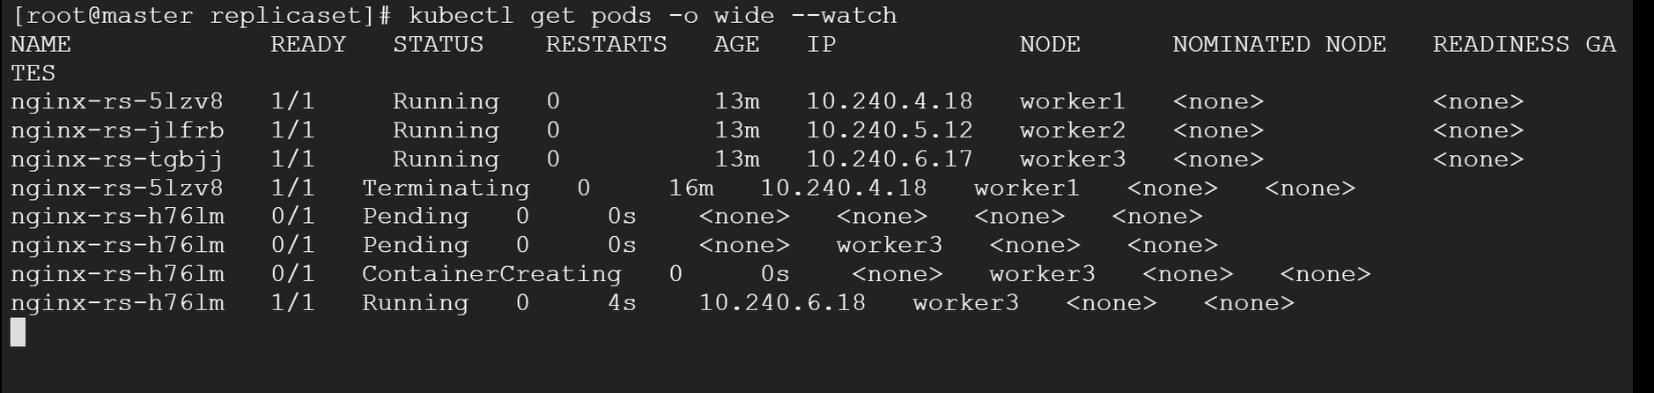

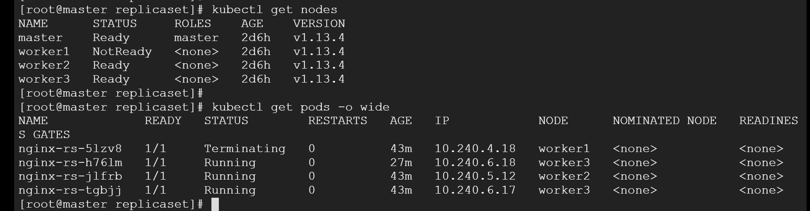

### Scaling up pods:

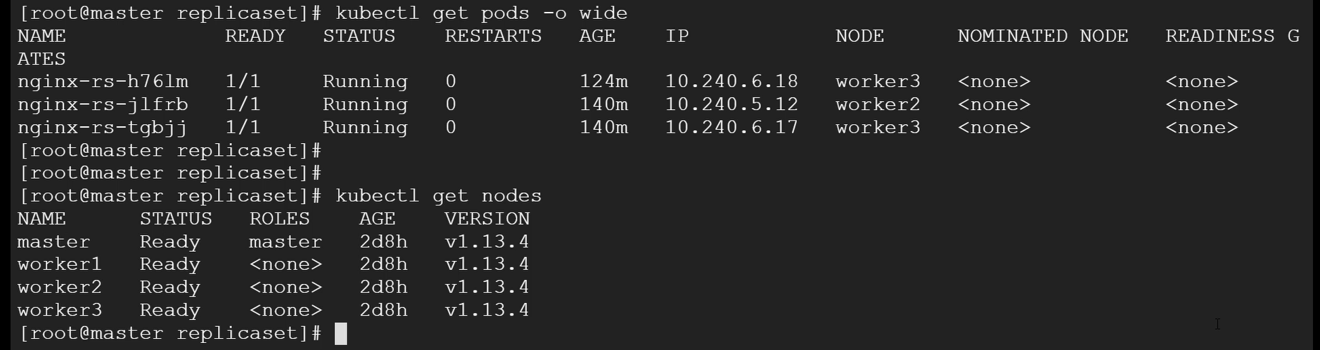

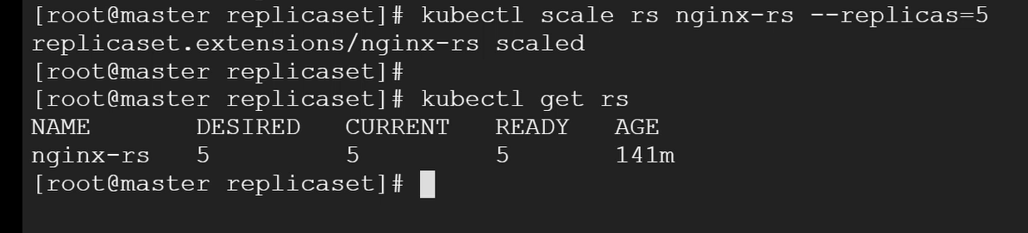

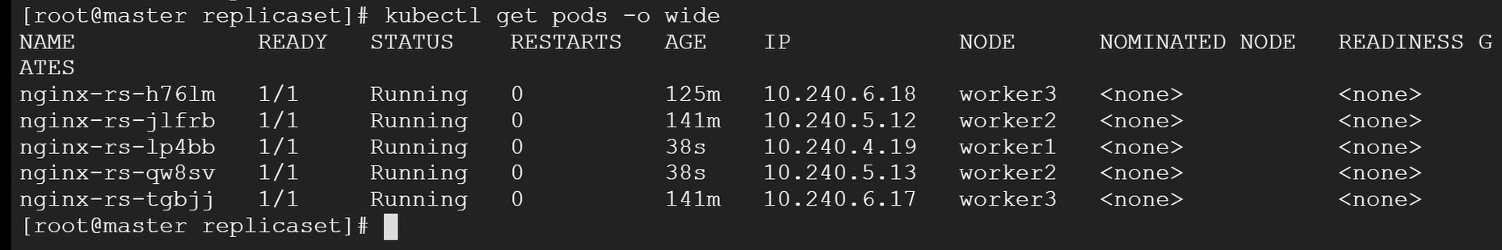

### Scaling down pods:

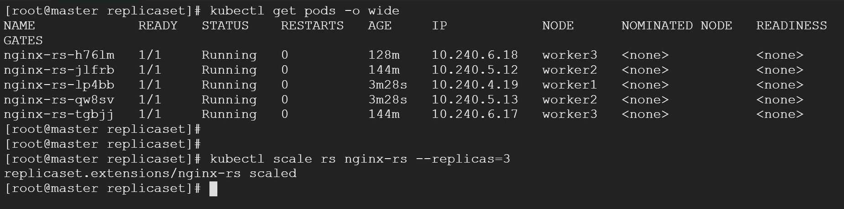

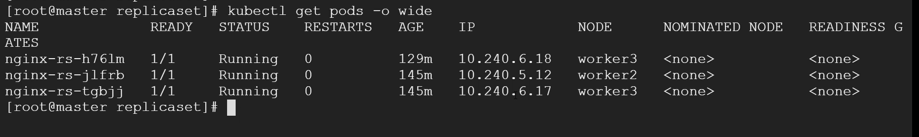

### Cleanup pods:

